**Natural Language Processing-NLP Top Projects**

[[Asad iqbal](https://medium.com/@deasadiqbal?source=post_page-----402de67aab0e--------------------------------)](https://medium.com/@deasadiqbal?source=post_page-----402de67aab0e--------------------------------)

[Asad iqbal](https://medium.com/@deasadiqbal?source=post_page-----402de67aab0e--------------------------------)

·

[Follow](https://medium.com/m/signin?actionUrl=https%3A%2F%2Fmedium.com%2F_%2Fsubscribe%2Fuser%2F7b3963afad1e&operation=register&redirect=https%3A%2F%2Fmedium.com%2F%40deasadiqbal%2Fnatural-language-processing-nlp-top-project-402de67aab0e&user=Asad+iqbal&userId=7b3963afad1e&source=post_page-7b3963afad1e----402de67aab0e---------------------post_header-----------)

5 min read

·

Oct 30

63

1

Delve into the thrilling realm of Natural Language Processing (NLP)! Witness the impact of NLP projects in our daily lives, from interactive conversational agents like Amazon Alexa to HubSpot’s insightful sentiment analysis feature and the language magic of Google Translate and Grammarly.

Whether you’re a curious developer or an inquisitive data scientist, why not take the plunge into the world of NLP and learn by doing? With powerful frameworks like PyTorch and TensorFlow, you can effortlessly launch a Python notebook and start crafting cutting-edge deep learning models within minutes.

Embark on a journey of hands-on NLP exploration with this article, where I guide you through five exciting projects you can start working on right away. Not only will these projects enhance your NLP skills, but they’ll also serve as impressive additions to your resume! Ready to elevate your NLP expertise? Let’s dive in!

**1. Paraphrase detection task**

Embark on a journey through the virtual realms of Quora, a treasure trove of knowledge and curiosity. Imagine a world where users weave a tapestry of questions and answers, creating a vibrant mosaic of experiences and insights.🌐

In the heart of this digital landscape, Quora issued a challenge to the brilliant minds of Kaggle: unravel the enigma of question pair similarity. Picture the task as a quest to determine if questions are soulmates or merely distant cousins.This intriguing endeavor goes beyond the ordinary — it’s a quest for the holy grail of high-quality answers. As Kaggle warriors, we are tasked with deciphering the code that enhances the Quora experience, turning each interaction into a symphony of wisdom that resonates from writer to reader.📜

Start project now → [Go To Dataset](https://www.kaggle.com/c/quora-question-pairs/overview)



**2. Paraphrase detection task**

Ever wondered how technology deciphers the hidden dance of words? Welcome to the intriguing world of paraphrase detection — a captivating endeavor that unravels the mystery of whether two pieces of text share the same essence. Brace yourself for a journey into realms where machines wield their prowess in translation, unearth plagiarism secrets, extract vital information, and craft succinct summaries. 🌐📜

Picture this: you’re about to dive into a realm where words transcend their literal meanings, and understanding the nuances becomes an art. The task at hand? Unveiling the profound connections between disparate text entities. This isn’t just about deciphering words; it’s about unlocking the magic of meaning. 🧙‍♂️🔍

Our voyage into the heart of paraphrase detection unveils two main protagonists: the similarity-based methods and the classification methods. These methodologies, akin to characters in a gripping tale, bring diverse strengths to the table. They navigate the intricate dance of language, determining whether texts are soulmates or mere strangers passing in the linguistic night. 🕵️‍♂️💬

So, gear up for an exploration that transcends mere words. Paraphrase detection isn’t just a task; it’s a gateway to a world where language reveals its truest colors. Join us on this odyssey, where meaning meets machine, and every word holds the potential for a revelation. 🚀📚

Start project now → [Go To Project Repository](https://github.com/wasiahmad/paraphrase_identification)

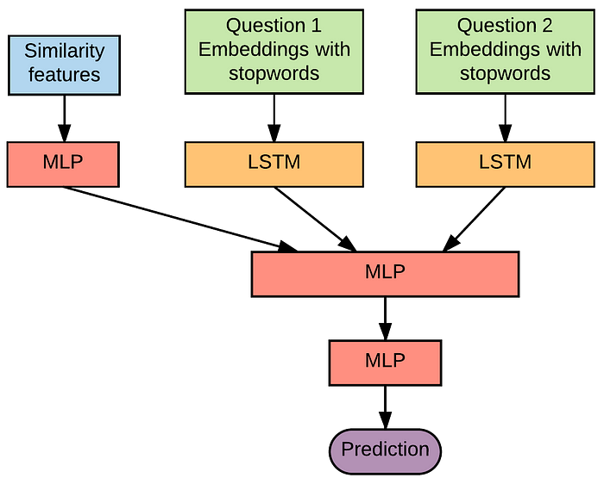

**3. Generating research papers titles**

Embark on a cutting-edge journey with our revolutionary project dedicated to crafting mind-blowing titles for scientific papers! 🌐📚

Picture this: a powerful GPT-2, supercharged and trained on a treasure trove of over 2,000 article titles sourced from arXiv, ready to spark your imagination! 🔍✨

But wait, there’s more! This isn’t just about scientific papers. This nifty application flexes its versatility muscles, allowing you to dive into text-generating feats like crafting awe-inspiring song lyrics, engaging dialogues, and beyond! 🎶💬

Oh, and did we mention the secret sauce? Brace yourself for a crash course in web scraping, as you master the art of extracting text from research papers to fuel your model’s training. 🕸️🤓

Start project now → [Go To Project Repository](https://github.com/csinva/gpt2-paper-title-generator)

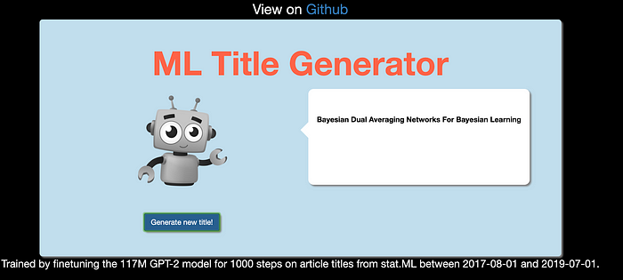

**4. RESTful API for similarity check**

🚀 Dive into an exciting journey with our latest project! 🌐 We’re crafting a mind-blowing Similarity Check API using cutting-edge Natural Language Processing (NLP) techniques. But hold on, it’s not just about coding magic with NLP tools! 🧙‍♂️

Picture this: not only will you master the art of implementing NLP wizardry, but you’ll also elevate your skills by unleashing the power of Docker to launch this API into the virtual skies! 🐳✨

Get ready for the thrill, because along the way, you’ll transform this API into a sleek web application, unlocking the secrets of building a complete NLP experience! 🚀📲

Ready to embark on this adventure? Start your project now and journey into the future of NLP innovation!

Start project now → [Go To Project Repository](https://github.com/thecraftman/Deploy-a-NLP-Similarity-API-using-Docker)

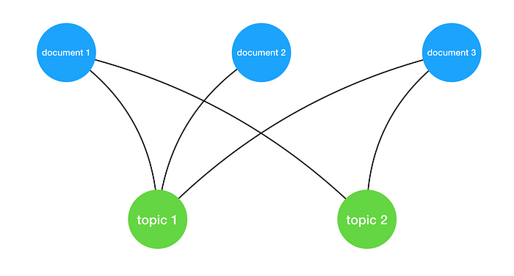

**5. Predict closed questions on Stack Overflow**

Calling all code maestros! If you’ve ever danced with the curly brackets, chances are you’ve waltzed through the virtual haven known as Stack Overflow — the sacred ground for all things programming!

Now, imagine this: a cosmic project where you’re not just deciphering code riddles but predicting the fate of each question. 🧙‍♂️ Will it soar to new heights, or face the dreaded closure curtain?

In this epic saga, our dataset is a treasure trove of insights — a digital Pandora’s box containing question titles, body texts, tags, creation dates, and more! 📦✨

From stellar inquiries to the occasional head-scratcher, we’re on a mission to unveil the mystery behind every question’s destiny. 🕵️‍♀️ Will it be hailed as a programming masterpiece or meet its closure demise? Only the dataset holds the key!

So buckle up, fellow coders, as we embark on a thrilling journey through the binary realms of Stack Overflow, armed with algorithms and a sprinkle of data magic! 🔮💻 Ready to predict, decode, and perhaps uncover the secrets of the programming cosmos? Let the adventure begin! 🚀

Start project now → [Go To Dataset](https://www.kaggle.com/c/predict-closed-questions-on-stack-overflow/data)

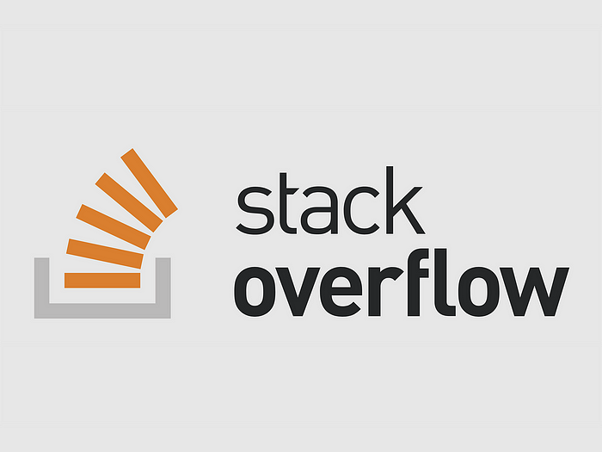

And there you have it! 🚀 Excited to see which project grabs your attention? Dive in, get your hands dirty, and let the NLP magic begin! 🧙‍♂️ Crafting tangible projects is the ultimate secret sauce to level up your skills, plus it’s a stellar boost for your resume.

That’s a wrap for now. 🎉 Thanks a bunch for tuning in! 👋 Happy coding! 🚀💻